Welcome to the Tennis Program at the Athletic Club of Bend, we look forward to having you in our program.

Any questions can be emailed to our Tennis Director Eric Lutz, Eric@athleticclubofbend.com

Your profile has now been created and you may now set it up, this can be accessed through the member portal on our website athleticclubofbend.com.

HOW TO SET UP ACCOUNT (use Google Chrome or Firefox web browser)
- Go to our website AthleticClubofBend.com’s Main Menu

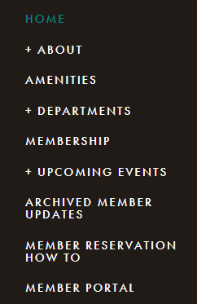

- From the Login Screen - Go to “Access my Account”
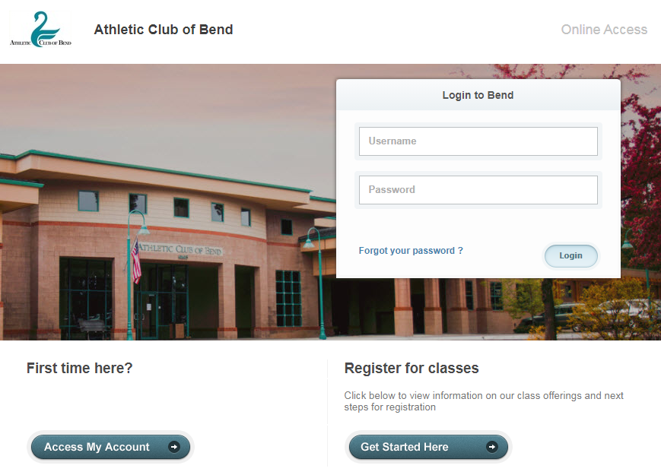

- Enter Name and email address, a link will be emailed to you to complete registration

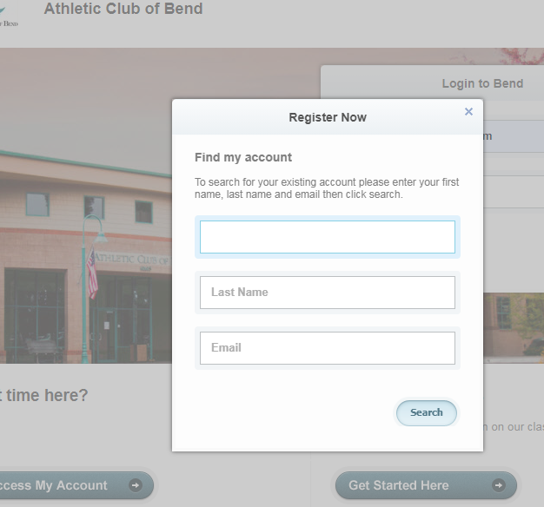

- Create Login and Password, you can now login into the member Portal

HOW TO REGISTER FOR CLINICS
1.From the Home Menu select “Group Activities”
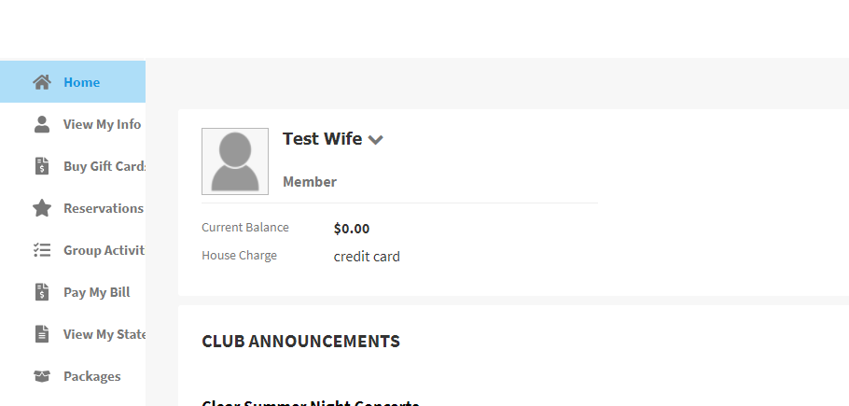

2. Select Clinic you would like to register for and select “sign up”
(schedule shows one week in advance)
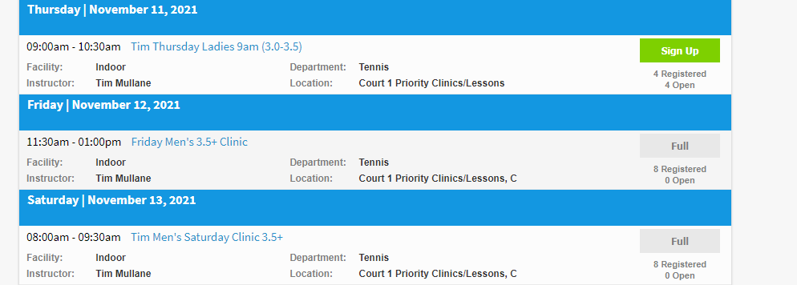

4. Court Reservations: Click on Reservations tab

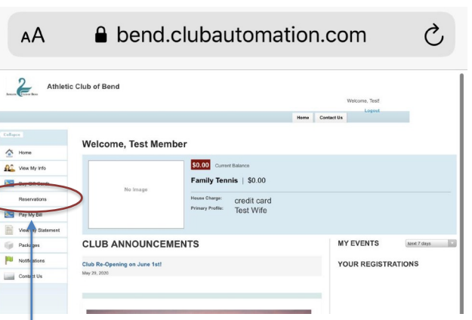

5. Click on Reserve a court, change the date if needed (reservations are allowed 3 days in advance)
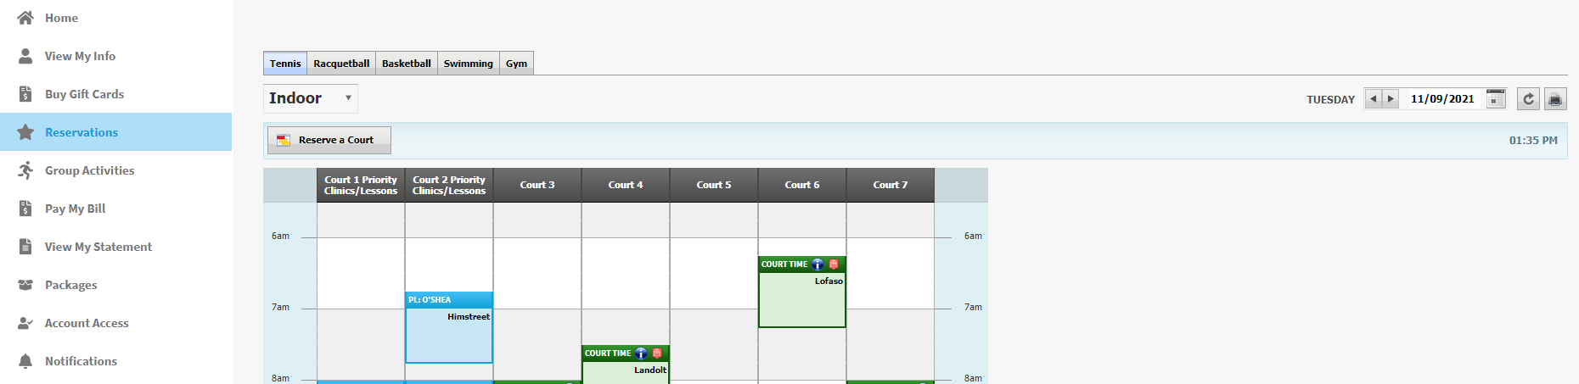

6. Select court and time (Green blue areas are already reserved) Each purple bar is 15 minutes.
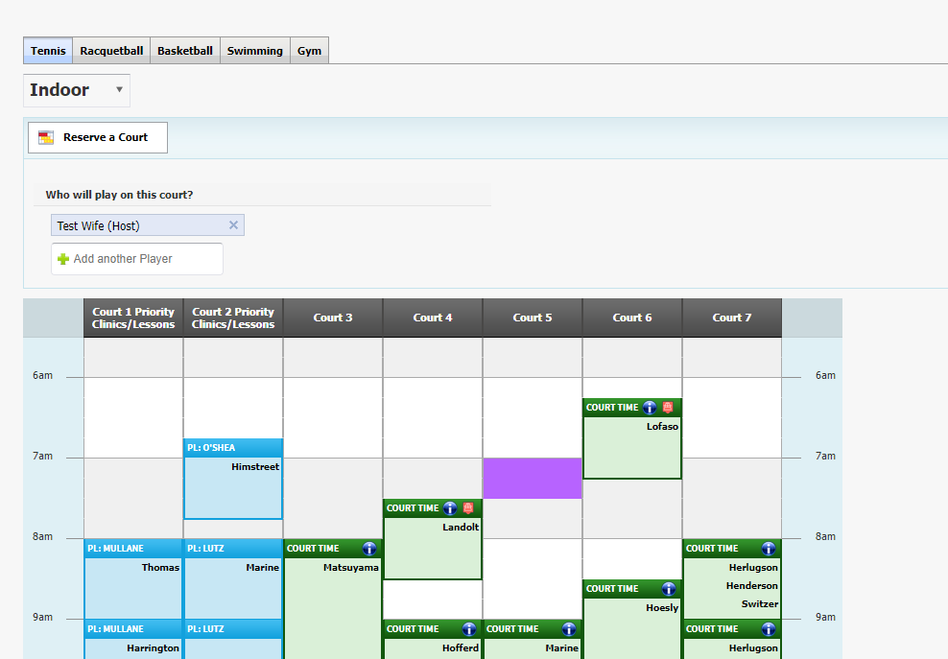

7. Click on Save Reservation on the right hand side of screen.
8. Please cancel reservation if not going to used.

