Athletic Club of Bend Member Portal Registration

Your profile has now been created and you may now set it up, this can be accessed through the member portal on our website athleticclubofbend.com.

HOW TO SET UP ACCOUNT (use Google Chrome or Firefox web browser)
- Go to our website AthleticClubofBend.com’s Main Menu

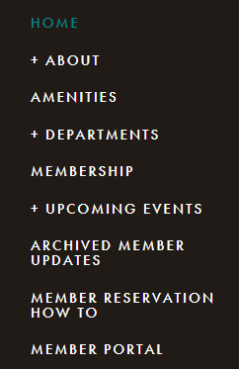

- From the Login Screen - Go to “Access my Account”
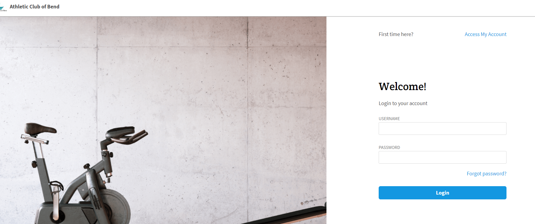

- Enter Name and email address, a link will be emailed to you to complete registration

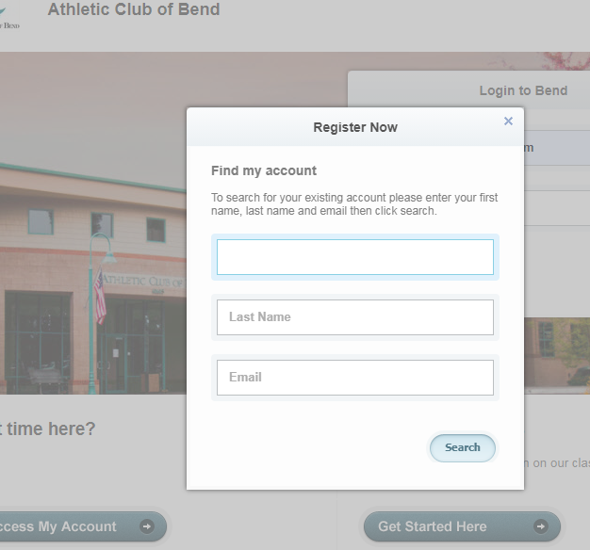

- Create Login and Password, you can now login into the member Portal

